Bahria University,

Karachi Campus



LAB EXPERIMENT NO.

06

LIST OF TASKS

|  |  |
| --- | --- |
| TASK NO | OBJECTIVE |
| 1 | **Using python implements VADER rules-based classification algorithm to find the sentiments of different sentences.** |
| 2 | **Using python implements textBlob rules-based classification algorithm to find the sentiments of different sentences and compare the results with task # 01.** |

# **Task # 1: Using python implements VADER rules-based classification algorithm**

# **to find the sentiments of different sentences.**

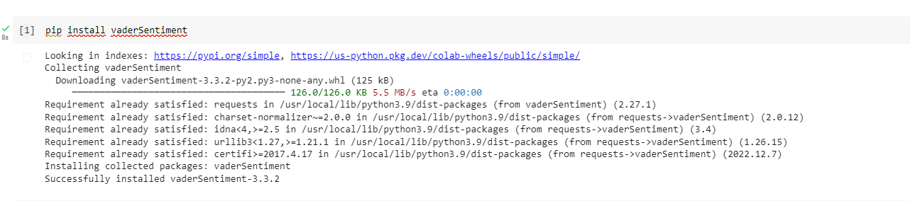

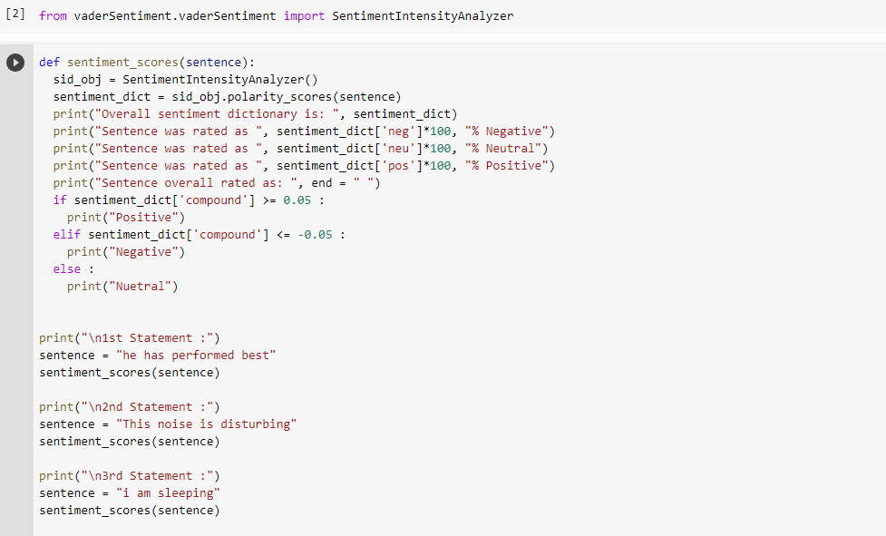

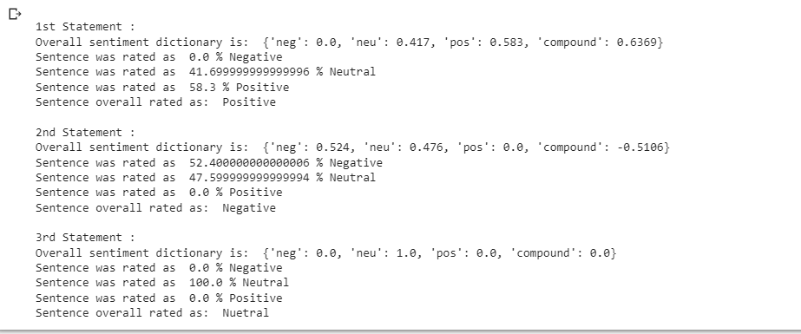

# **Task # 2: Using python implements textBlob rules-based classification algorithm to find the sentiments of different sentences and compare the results with task # 01.**



